NJ Eastern Star Home
November 2022
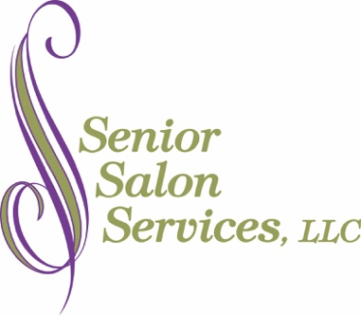

Women’s Services
Shampoo 7.00
Conditioner 6.00
Women’s Dry Haircut 20.00
Women’s Shampoo & Haircut 25.00
Shampoo & Set 23.00
Shampoo, Cut & Set 34.00
Shampoo, Blow Dry & Curl 26.00
Shampoo, Cut, Blow Dry & Curl 36.00

Men’s Services
Shampoo 7.00
Conditioner 6.00
Men’s Dry Haircut 18.00
Men’s Shampoo & Haircut 22.00
Beard Trim 6.00
Moustache Trim 6.00
Wax Services
Eyebrow Wax 11.00
Lip Wax 9.00
Chin Wax 9.00
All Three Facial Waxes 29.00
Chemical Treatments
Color Rinse 7.00
Color, Shampoo & Style 37.00
Color, Cut, Shampoo & Style 47.00
Permanent, Cut, Shampoo & Style 58.00
Partial Highlights, Shampoo & Style 47.00
Partial Highlights, Cut, Shampoo & Style 57.00
Full Highlights, Shampoo & Style 67.00
Full Highlights, Cut, Shampoo & Style 77.00
Other Services
Wig Service (Additional) 12.00
Bedside Service (Additional) 12.00

