Dear Fellow Chapter Members, Family and Friends,

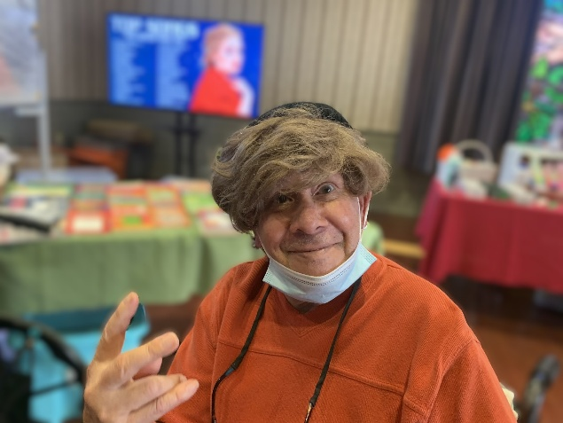I hope this message reaches you in good spirits. On behalf of the residents, as well as myself and my team, we want to express our heartfelt thanks for your continued support and generous contributions to our community of volunteering, birthday bags, boutique items and activity supplies. Your kindness truly makes a difference.

We are deeply grateful for your continuous dedication to our facility, which has made it possible for us to organize a variety of meaningful recreational programs that our residents can enjoy, giving them the chance to nurture and enhance their personal strengthens and interests.

Every month, our residents eagerly anticipate our Boutique program – a social gathering that brings joy to all who attend. Over the past few months, we've also been thrilled to offer programs that allow our residents to make a positive impact in our community through service. Together the residents, their families, and our staff came worked together to make hygiene bags for those less fortunate. We have also had the privilege of having the Mayor of A person opening a small plastic bag
Bridgewater come and join us at our community to help us celebrate not one, but two of our residents turning 100 and 103. Our residents have also been enjoying taking part in our daily televised programs on our new in-room tv channel including our weekly Sunday Services and exercise programs.

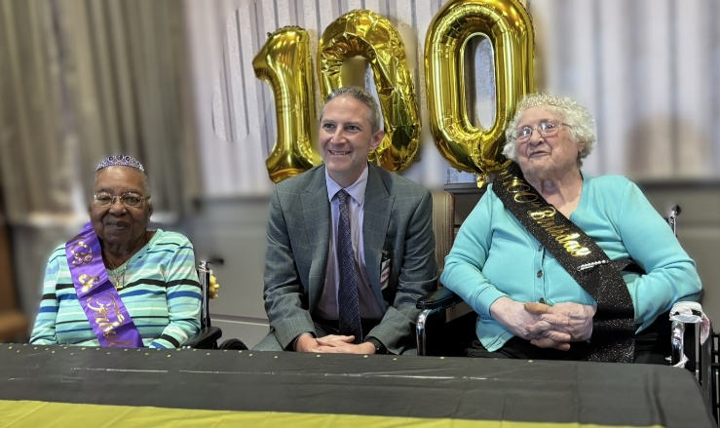I am reaching out to see if you would be willing to help me spread the word around the community to see if anyone would be interested and willing to donate supplies to help enrich our seniors through programming and more as well as, to our monthly boutique.

As always, any donations are greatly appreciated.

Thanks for your time.

Kindly,

Simone Rudich

*Director of Activities*

New Jersey Eastern Star Home

908-722-4140 ext. 3527



|  |  |
| --- | --- |
| * Shampoo   **Boutique and Donation Items List**   * Conditioner * Liquid Hand Soap * Perfume * Cologne * Watches * Pencils * Yarn * Crocheting Hooks * Large Print Reading Books in (Polish and Spanish Translation) * Pens * Wallets * Jewelry for men and women * Word puzzle books * Batteries | * Chips * Colored pencils * Mini Hershey bars * Fruit Snacks * Zero Sugar Sodas * Vegetable Juice * Pencils * Cookies * 100 calorie packs * Chips * Dark Chocolate * Stuffed Animals * Hair Accessories * Any donations are appreciated. |