Do Disney in a Day!

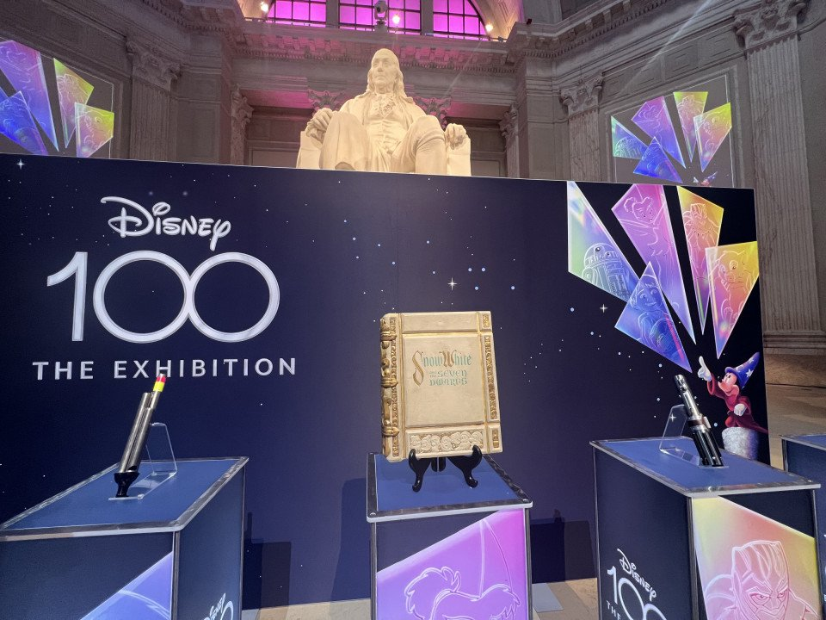
Join NJ OES as we take a trip to “Disney 100: The Exhibition”
The Franklin Institute, 271 N 21st St Philadelphia, PA
Sunday, July 30, 2023
2:00pm (This is a timed ticketed exhibit)
Fee: Ages 12-64 $45.00; 65+ $43.00; Children 3-11 $41.00.

All Masonic organizations and their families are welcome to join us on this day!
Expect to spend at least 1-1 ½ hours in the Disney 100 exhibit. Some folks may take longer.
Your ticket purchase includes admission to the Franklin Institute and a Fels Planetarium show, all to be experienced at your own discretion.
+++++Please join us in the Atrium Area at 1:45pm before entering the exhibit for a Group Picture++++
Transportation and ticket purchases are ON YOUR OWN. Onsite garage parking is available. Main entrance to the Museum is located on N 20th St.
How to purchase tickets (screen by screen instructions): www.fi.edu. Click on Disney100: The Exhibition Buy Tickets (yellow oval). Click on Buy Tickets (black oval). Select Daytime Admission: Disney 100:The Exhibition + Museum Access. Go to gray bar and use the calendar option to select the date and select the time. Add your tickets to your Cart; click cart and pay with a credit card. You’re set to go!
Questions? Please contact Nancy Rudolph Myers, GR of OK in NJ Nanisworld@aol.com
Should you decide to stay in the city and dine on your own, here are a few restaurant recommendations courtesy of Nancy Rudolph Myers & Ed Myers (my hubs!). All have websites.

If eating beforehand: The Reading Terminal Market; 1136 Arch St. Tons of choices. We love Molly Malloy’s. The Market can be crowded, be prepared and plan accordingly. Will NOT be open after our tour of the exhibit.

For after our tour (reservations always recommended):

Maggiano’s Little Italy; 1201 Filbert St. Casual Italian. Great spot for small or large groups.
City Tap House; 2 Logan Square. Sports Bar type atmosphere. Walking distance to the Institute.
The Urban Farmer; 1850 Benjamin Franklin Parkway. Slightly more upscale, but still casual. Has a Bar Menu as well. Walking distance.

If you’re feeling a little more adventurous:
Dante & Luigi’s; 762 S 10th St (Bella Vista section of South Phila). Our absolute FAVORITE Italian spot in the city. Still casual (nicer attire is always better). Upscale atmosphere. Restaurant established 1899. Owners are the best. Reservations highly recommended.
Spasso Italian Grill; 34 S Front St. (Old City). Casual. Keep this one in mind for the future especially if you’re going to events at the Sports complex. It has easy access to 95.
For a total Philly experience, skip Pat’s & Geno’s and head to Tony & Nick’s Steaks; 39 E Oregon Ave. My hubby swears by the pork & broccoli rabe sandwich, I love the Uncle Mike hot sandwich. The hoagies are fantastic (it’s all about the roll & the PICKLE! Sweet & hots are great too!).
Another steak spot recommended by Zack Myers (professional musician, no relation) Ishkabibble’s; 337 South St & 517 South St (has more seating). Don’t expect fancy schmancy here – just great food. South St can be crazy fun but can be quite chaotic. Prepare accordingly!

