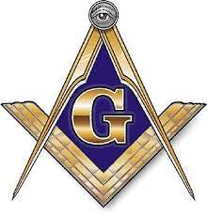
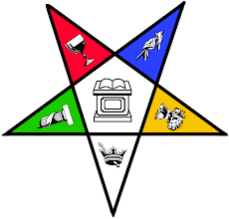

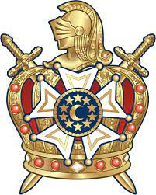

UNITY DAY

You’re cordially invited to…
enjoy an afternoon of
FOOD, FELLOWSHIP & FUN

A good time
will be had by all.

You won’t want to miss this afternoon of enjoyment
DATE: TIME:
July 17, 2022 12:00 – 4:00

WHERE:
Tall Cedars Picnic Grove
245 Sawmill Road
Hamilton Twp.
NJ
08620

Kindly RSVP by July 10, 2022
To:

Bob & Elaine Parsons
Grand Chapter
Order of the Eastern Star of
New Jersey
Rainbow & DeMolay Liaisons

609 267 8345
501 Homestead Avenue
Mount Holly NJ 08060
bobandelaineparsons@yahoo.com

Sandwich Choice:
Roast Beef, Turkey or Vegetarian
$15.00 Per Person
Check Payable to: Robert or Elaine Parsons

