YOU’RE INVITED TO THE 2ND ANNUAL
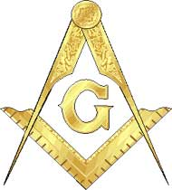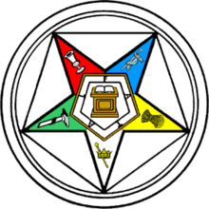

NJ OES GRAND CHAPTER & Grand Lodge of NJ
Master Mason Night
Where the Grand Chapter of New Jersey will honor MW Robert V Monacelli and all Master Masons of NJ
Saturday, September 11, 2021
Social Hour 5pm—Dinner 6pm—Program 7:30 pm
Masonic Fellowship Hall-1114 Oxmead Rd., Burlington, NJ 08016
Buffet Dinner: Chicken Pot Pie, Meatloaf, Mashed Potatoes, Fresh Vegetables, Salad, Bread/Rolls, Dessert, Soda/Water/Coffee. Cash Bar
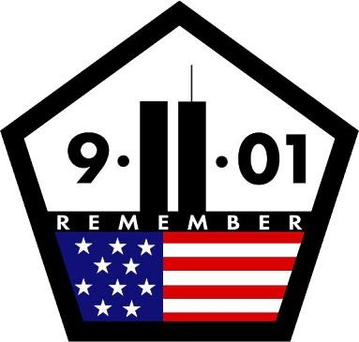
Guest Speaker:
This Photo by Unknown Author is licensed under CC BY-NC
RW Moises Gomez, Grand Historian
Commemorating the 20th Anniversary of 9/11
Musical Selections
Open to all Master Masons, Eastern Star Members, as well as family and friends of Freemasonry
Attire: Business Casual
RSVP by: Friday, September 3rd
Make Checks payable to: Grand Chapter Voluntary Donations Subscription: $35.oo per person
Send Checks to: Joanne Byrne, RWGC
186 Washington Place
Totowa, NJ 07512
973-942-8134/973-865-4653

Name______________________________________________________________# of people attending_____________

Title__________________________________________________Lodge/Chapter & District_______________________

Phone_____________________________Email__________________________________________________________
Any special dietary restrictions must be submitted with this reservation
Please list additional Guest(s) and info on the back of this form
Tables of Eight to Ten can be reserved by sending reservations in together

